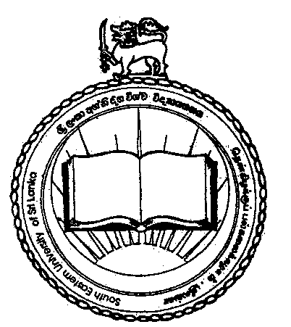

13th GENERAL CONVOCATION - 2019
South Eastern University of Sri Lanka

Thirteenth Annual General Convocation of South Eastern University of Sri Lanka is scheduled to be held on 16th and 17thMarch 2020 at South Eastern University of Sri Lanka, Oluvil. The Convocation will be held in three sessions for internal graduands.

16.03.2020 from 8.00 am onwards (Session I) Faculty of Applied Sciences
Faculty of Arts and Culture

16.03.2020 from 2.00 pm onwards (Session II) Faculty of Engineering
Faculty of Islamic St. & Arabic Lang.

17.03.2020 from 8.00 am onwards (Session III) Faculty of Management & Commerce

Issue of Cloaks & Garlands

Cloaks, garlands and passes etc. can be collected at the following collecting points on 07th March 2020 (Saturday) between 9.30 am to 03.00 pm.

Graduands of Faculty of Applied Sciences at Staff and Welfare Division, SEUSL, Oluvil.

Graduands of all other faculties at their respective faculties,SEUSL, Oluvil

In order to obtain the convocation cloak and garland, the graduands should produce the student Record Book or Student Identity Card.

Rehearsal of Convocation Procession

A Rehearsal of Convocation Procession is also scheduled to be held on 07.03.2020 at SEUSL, Oluvil. Hence, all graduands are requested to gather at 12.30 pm on 07.03.2020 (Saturday) at the Lobby of the Faculty of Engineering, SEUSL, Oluvil.

The detail of graduands to be conferred degrees at the convocation is appended.

Registrar
SEUSL

