First name First surname⁽¹⁾, Second name Second surname⁽²⁾, Third name Third surname⁽³⁾

Title of Contribution for Second Annual Conference, SEUSL (do not exceed 75 characters including spaces)
- University of the Moon, Centre for Disaster Studies, CityName, Address and civic number, +734 384 8798 9
- University of Kalgan, Department of Sciences, Kalgan

Abstract This is an example text template for the paper submission (Camera ready copy) at the 2nd ARC of SEUSL. The Abstract should be concise and self-contained. The abstract must not be longer than 150 words. Non-standard abbreviations and specific nomenclature of materials must be avoided. The style to be used, according to the Template Style List, is the Normal Style without right indentation. At the end of the abstract text a list of keywords ( maximum: 5) should be added as follows. The paper size should be A4 size (210 mm × 297 mm). The paper length is 6~8 pages. Please submit both word file.

Keywords keyword1, keyword2, keyword3…

General body of the manuscript
The main text of the paper should be formatted using Normal Style according to the Template Style List. The first paragraph of each Section should not have right indentation whilst following paragraphs should, as in the following.
Right indentation is of .8 cm (as per Template Style Normal). The Normal style is based on the Constantia font, available within Microsoft Word software in all recent releases, size 10. Line spacing is single. The page format must be strictly respected as per Template Page Format. In particular, two columns formatting with column width of 8.85 cm and column spacing of 0.8 cm should be used. Page margins are: Top 2.5 cm; bottom 2 cm; Internal side 1.5 cm; External side 1.0 cm. Please ensure to respect the paper template which has different margins for right and left pages to allow for double-sided printing.

Sections of the manuscript

How to start?
Copy the template file, TemplateWLF2.doc, to the template directory. This directory can be found by selecting the Tools menu, Options and then the File Locations. When the Word program is started, open the File menu and choose New. Select Templates, On my computer, and then the template, TemplateWLF2.doc.
Please rename the document before you start writing your paper. The file name of the manuscript should include the abstract/paper ID and the last name of the corresponding author. For instance, if the Abstract/Paper ID is 170 and the corresponding author is Wang, the file name is 170_Wang.

Section and sub-sections
Each manuscript section should be entitled according to the Template Style List using up to 3 levels of indentation: style Heading 1 for the main title of the section, style Heading 2 for a possible sub-section and, if needed, style Heading 3 for a further sub-level. We recommend not to use more than 3 levels on titles and sub-sections. The example up here shows the use of two levels of titles for section and sub-section heading.
The font to be used for all Headings is Calibri. Heading 1 has font size 11, typeface bold and colour blue with RGB=(0,102,153). Heading 2 has font size 10, typeface bold, black colour. Finally, Heading 3 has font size 10, typeface bold + italic, black colour. However, please choose the correct style in the Style List of the Template file so that formatting is automatically applied to avoid mistakes.

Figures and figure captions
Figures are allowed either in greyscale or in colour. It is possible to insert column-wide figures (half-page width) with maximum width of 82 mm and double-column-wide figures as well with a max allowed dimension of 170 mm. In any case, the max height is 230 mm Figure should be directly attached within the document at the right place using preferentially the “insert -> image -> from file” option of Microsoft Word using a recommended resolution of 400 dpi for greyscale images and of 300 dpi for colour images. TIFF format is recommended.
The following is an example of column-wide figure. The figure line (the line of text in which the figure has to be placed) should be formatted choosing the appropriate Style “Figure” from the Template Style List. This will ensure proper distancing between figure and surrounding text. However, authors are free to add one or two empty rows of normal text to adjust formatting and visual appearance.
Figure 1 Example of half page figure. Captions which are 2 or more rows long must be justified. Shorter caption must be column-centred. Please ensure to select the style “Figure Caption” and to place caption below figure. Figures should be cited in text using the short: “Fig.”.

Title, authors, affiliations and other issues

Title and authors
The paper should start with the title section which has a special single-column formatting (see top of first page). Please make sure to maintain section separation to ensure proper column formatting of the document. In case you inadvertently delete the section break, insert a new one on top of the beginning of manuscript main body using Microsoft Word option “insert -> break -> section break -> continuous”.
Author’s names should precede paper title as in the example above. Please use style “Authors” for this part of paper, which uses the following formatting: font Calibri, font size 12, typeface bold, colour black, left indent 5 cm, vertical spacing after 3 pts. Each author has to be followed by a superscript number in parentheses corresponding to the author’s affiliation (see also below).
The title has to be formatted using the style “Title” reflecting the following format: font Calibri, font size 16, typeface bold, left indent 5 cm, justified, vertical spacing before 6 pts, after 12 pts, colour blue RGB=(0, 102, 153). The title should follow, according to the ICL journal “Landslides” style, the author’s names.
Finally, Affiliations conclude the first section of the paper, according to the style “Affiliation” in the Style List of paper Template. Each affiliation must be preceded by the relevant number between parentheses as in the example at the top of this file. Affiliation formatting is: font Calibri, font size 9, typeface bold, colour black, left indent 5 cm, vertical spacing after 3 pts. Each affiliation must be placed on a separate line, using the following order: Department/Branch/Office, Institution/University, Address, Country. For the affiliation of the corresponding author also the following information must be included: email and/or telephone number.
Each author should also define a short or “running” title to be used in the right page heading (see example above in the page heading where the Template has the sentence “F. Author, S. Author, T. Author – Running title of contribution”). The running title should be limited to a maximum of 70 characters, blank spaces included. The page headings have a specific style “Page heading” to be used.

Maths and formulas
All mathematical notations should be kept outside normal text paragraphs with the exception of single (or very simple combination of) symbols. An example of use of in-text symbols is this: β is defined as the slope angle in degrees. More complex expressions should be placed under the style “Equation” and inserted in the manuscript as equation objects using the proper Microsoft Word commands (such as e.g. “insert -> object -> Mathtype”). Please avoid copy-pasting of equations as images. If equation numbering is necessary, please use a right-sided numbering between squared parentheses as in the following example.

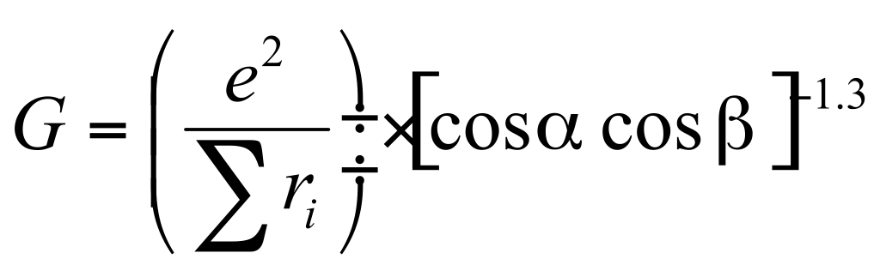 [1]

All the units of measurement used in the paper should be in the SI system and every time a new symbol, group of symbols or specific operator is introduced, it should be explained and described along with its unit of measurement if appropriate.

Tables
In all the manuscript, table have to be formatted according to the following example. It is possible to insert a single- or a double-column table (if needed) provided that the author insert the proper section breaks to ensure column formatting separation between sections.
Table format has to be copy-pasted from the example below, using font Calibri, font size 9, column heading colour white, text colour black.
Table caption must precede the table, and has to be formatted according to the style “Table caption”. Maximum table width is 82 mm for single column tables and 170 mm for page-wide tables.

Table 1 Example of table. Colours, formatting and fonts are as per template (Calibri 9 pt). Please ensure left justification for alphanumeric text and right justification for numbers. Use same number of decimals with floating point numbers. Table should be cited in text using the short: “Tab.”.
Col Head 1 | Col Head 2 | Col Head 3 | Col Head 4
Text | 34.90 | 17/11/2011 | Descr 1
Text | 12.98 | 01/06/1998 | Descr 2
Text | 3.64 | 31/02/1900 | Descr 3

In particular, Table colour is as follows: heading row and grid: blue RGB=(0,102,153); normal text rows: light cyan RGB=(204,236,255).
It is possible to add page-wide sections (using the appropriate section breaks as explained and as exemplified below, to insert large figures. The maximum allowed width is 170 mm. Also remind that max allowed height for both figures and tables is limited to 230 mm. Please remember that is this case you need to insert two section breaks (continuous): one just before the figure which starts single-column style, and the other one just after the figure caption, which tells the system to stop single column formatting and go back to double-column.
Please position your large figures in the best way, as to avoid large empty spaces on page.
In case this is not possible, add empty rows typing carriage-return characters until the visual appearance of the page is maintained, as in the following example.

.

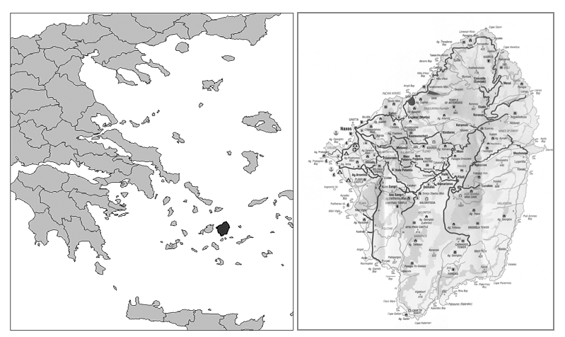
Figure 2 Example of two-column figure. In case the caption of the figure is only one row, it must be centred.

As in the figure above, use row spacing also to ensure a proper distance between figure and text according to the overall dimension of your image and caption length.
We suggest that each paper will have at least one Introduction section laying out the state of the art and the motivations for the study to be reported, a Materials and Methods section, one of Results and one incorporating Discussion and relevant conclusions as derived from the research outcomes.
The papers presented at the Second World Landslide Forum should follow the rules depicted in this Template Guideline and, furthermore, have a minimum length of 4 and a maximum length of 8 pages.

Acknowledgments
In the Acknowledgments section, appearing just before the References, the authors may credit others for their guidance or help. Also, funding sources may be stated. The Acknowledgments section does have a section heading at level 1, as in this example. Following this section the References section begins for which authors must use the style “Reference” (Font Calibri, font size 9, first row left indented 0.4 cm) and use reference citation rules as per the journal Landslides. Please follow the rules of the same journal also for citations within the text body.
In the following section we present some example of formatting for references related to edited books, conference proceedings, periodic journal papers, scientific reports and web sites. References must be, firstly, in alphabetical order and then in date order, descending.

References (in the alphabetical order)
References are cited in the text using Harvard method of citation

Web_site_author_name_surname A A, Author_surname B B, Author C, (2009). Title of Page. URL: http://_ [Last accessed: full date].

