SOUTH EASTERN UNIVERSITY OF SRI LANKA
STAFF DEVELOPMENT CENTRE

4.4 Quality Management and Administration

- Introduce systematic need analysis of demand and supply of employees; SDC

  - As per the Commission Circular No. 937 dated 10.11.2010;
S/N | Demand of Employees | Supply of Employees
01 | Director (1) | Available in Part Time basis
02 | Programme Manager (Assistant or Senior Assistant/ Deputy Registrar function as PM) | AR/ Establishment has been recommended to appoint
03 | Audio – visual Technician/ Officer | Nil
04 | Computer Application Assistant | Nil  (One who attached at the Career Guidance Unit is sharing now)
05 | Labourer | Available  (One who has been attached on hourly basis)

- Develop an annual staff training plan SDC Book & budget

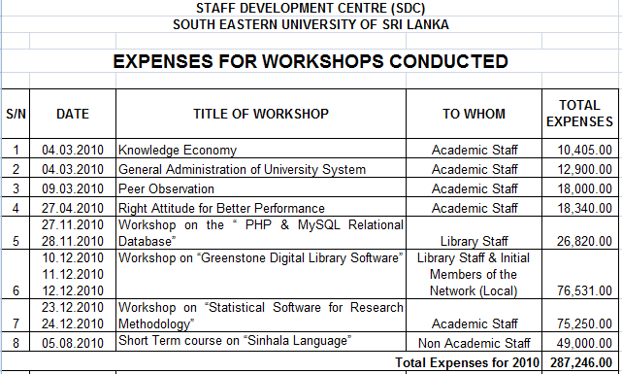

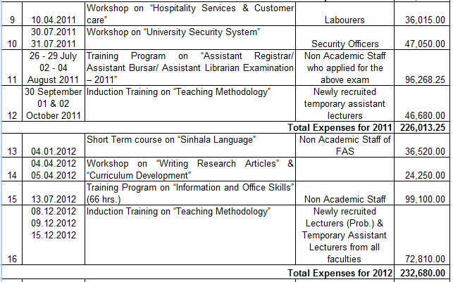

- Assess the needs and set up a fully fledged staff development unit to cater to all levels of staff SDC new building

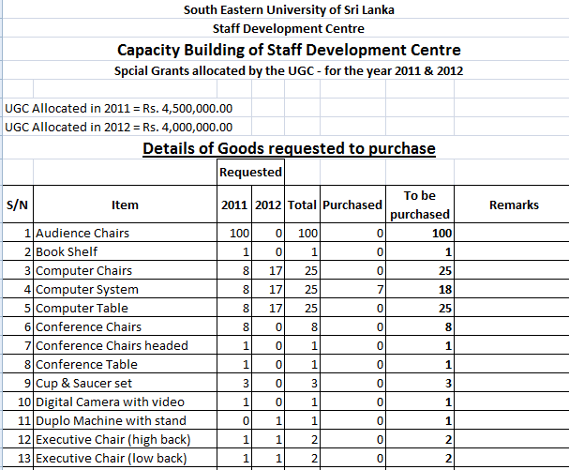

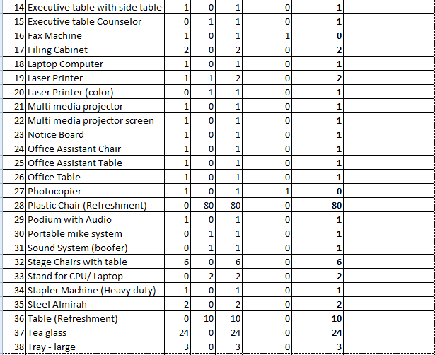

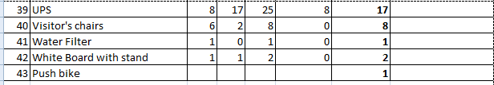

- Develop an annual staff training plan SDC Book
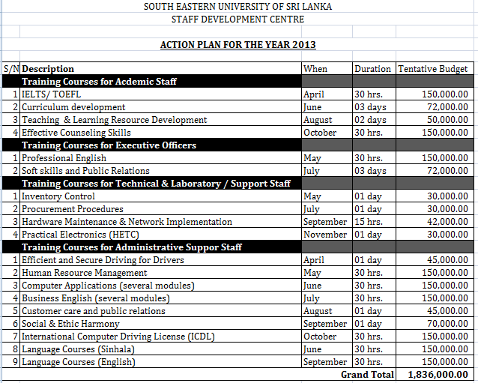

- Secure funding for staff development SDC & Bursar

