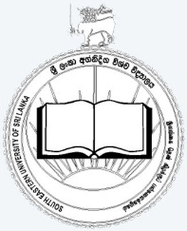 | 8th International Symposium  South Eastern University International Arts Research Session -2019  [SEUIARS]  Faculty of Arts and Culture  South Eastern University of Sri Lanka

Name in full
(use block letters) underline the surname
Designation
Organization

Mailing Address
E-mail Address
Telephone No(s).
Fax
I will present a paper / participate in the session. (please delete whatever inappropriate)

Title of paper
(if applicable)

Author(s) | - ……………………………………………………………………………………………………..  - ……………………………………………………………………………………………………..  - ……………………………………………………………………………………………………..  - ……………………………………………………………………………………………………..

Registration Form

Date: ……………................. Signature: ………………………………..

Payment can be made by depositing cash or sending a Bank Draft. Payment should be made to the following Account Number in favor of Bursar, South Eastern University of Sri Lanka (SEUIARS 2019) People’s Bank, Sammanthurai (Branch Code: 064), A/C: 064100160000950

Completed registration form together with the draft or copy of bank receipt should be sent by E-mail (intsym2019arts@seu.ac.lk) to reach the SEUIARS Secretariat by 10th December 2019.

